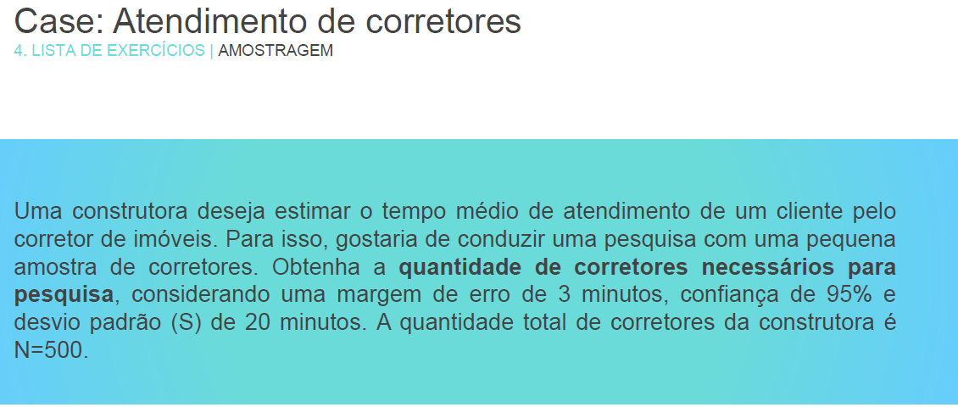

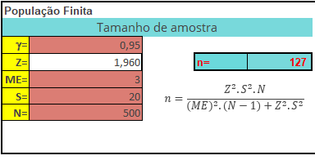

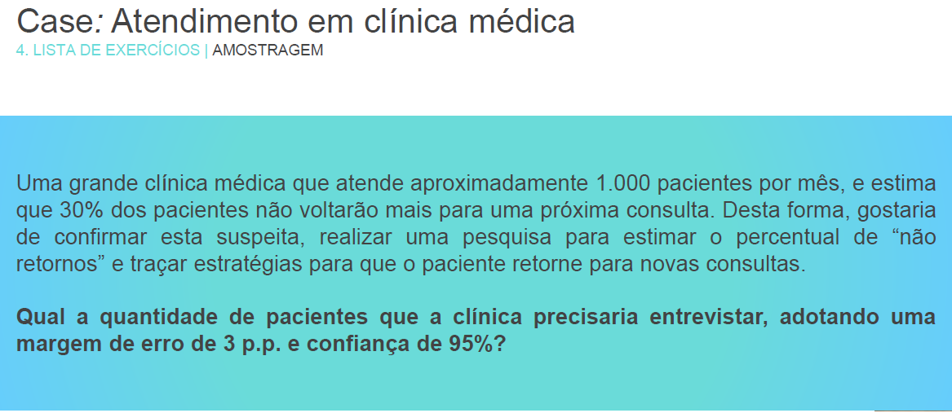

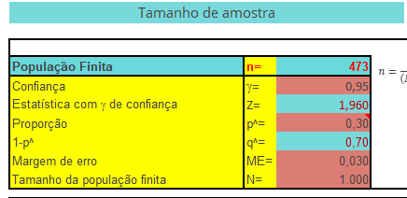

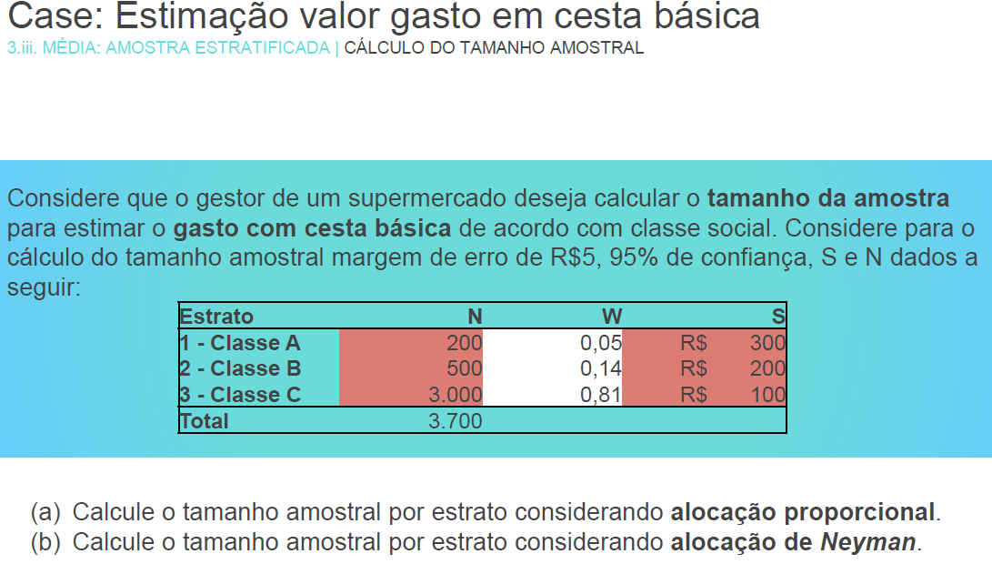

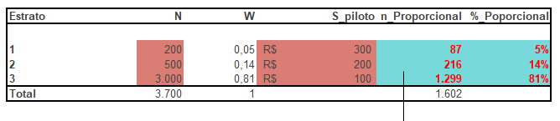

|  |  |  |  |  |  |
| --- | --- | --- | --- | --- | --- |
| **Estrato** | **N** | **W** | **S_piloto** | **n_Neyman** | **%_Neyman** |
|  |  |  |  |  |  |
| **1** | 200 | 0,05 | R$ 300 | **142** | **13%** |
| **2** | 500 | 0,14 | R$ 200 | **237** | **22%** |
| **3** | 3.000 | 0,81 | R$ 100 | **710** | **65%** |
| **Total** | 3.700 | 1 |  | 1.088 |  |